Consultancy Heavy Transport
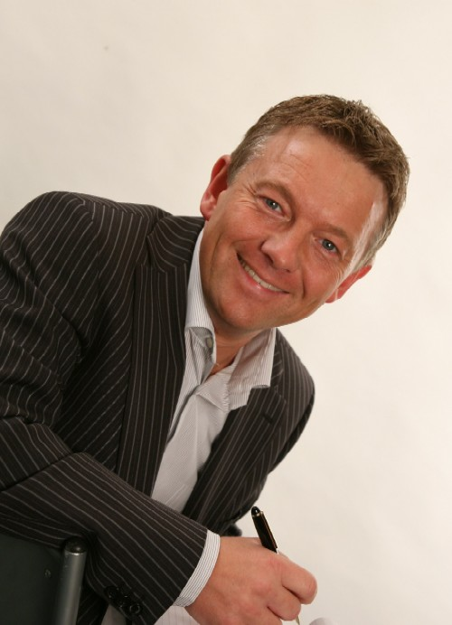 |  | - Static and rolling cargo  - Wind energy Turbines  - USPs of 300 + transport companies  - SPMT's, semi's and trucks  - Special vehicles + development  - Licensing system NL and Europe  - Transport Rates and turnaround times  - Choice own transport or outsourcing  - Shipment worldwide breakbulk  - Agents in all ports  - Construction and Ro - Ro  - Hiring cranes, heavy lift and installation  - Interim management and sales | 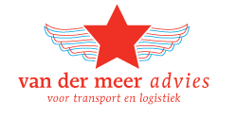
 |  |  | Adres  Phone  Bank  Kvk | De Line 16  8411TV JUBBEGA  +31 6 46 84 23 31  NL21 RABO 0144 2965 86  011.177.76  www.vandermeer-advies.nl  www.interim-xl.com
For Transport  Companies |  | - Interim management board, planning, fleet management, sales or licenses  - Fleet management, consultancy and advice choices  - Business development: finding new clients in Europe  - Project work on large jobs  - Assistance and guidance in large tenders
For  Customers |  | - Consultancy in transport choices, assisting in tenders  - Quick Scan current situation  - Choice own transport versus outsourcing
Internet |  | - Development of Websites, Google optimization for heavy transport  - Implementation of TMS and GPS software
experience with
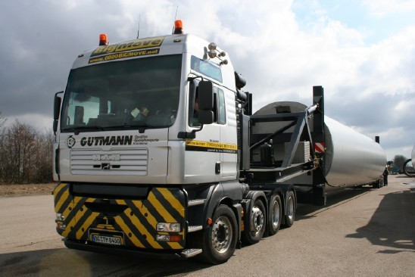  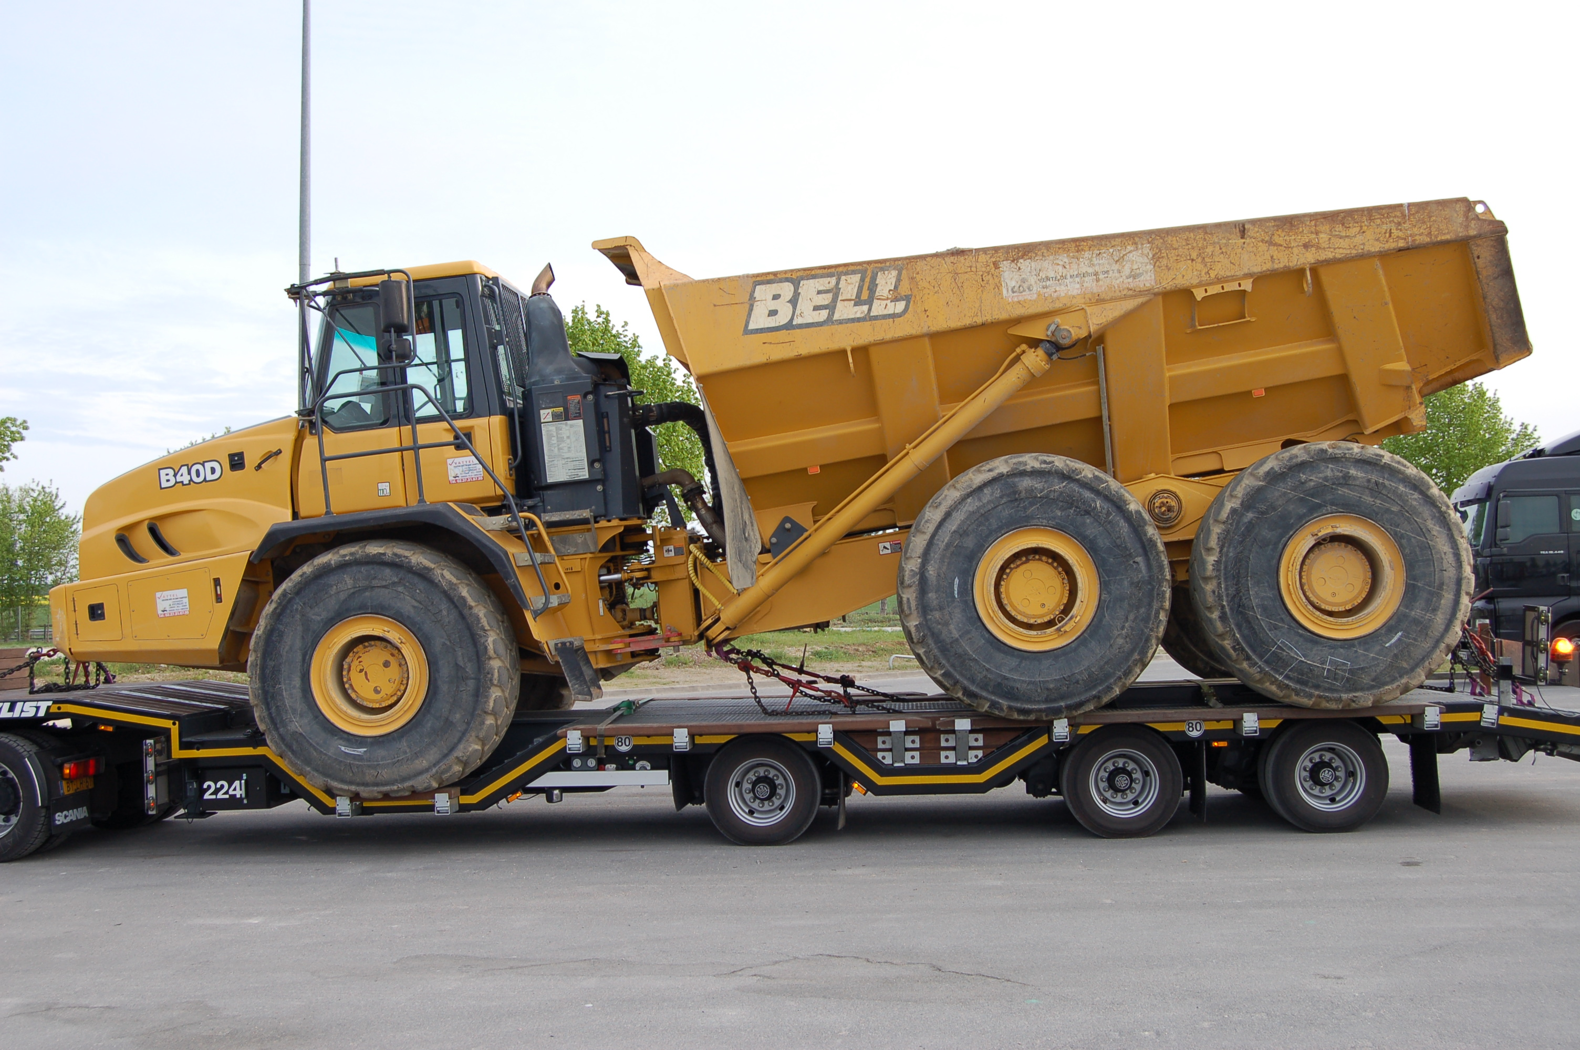 | 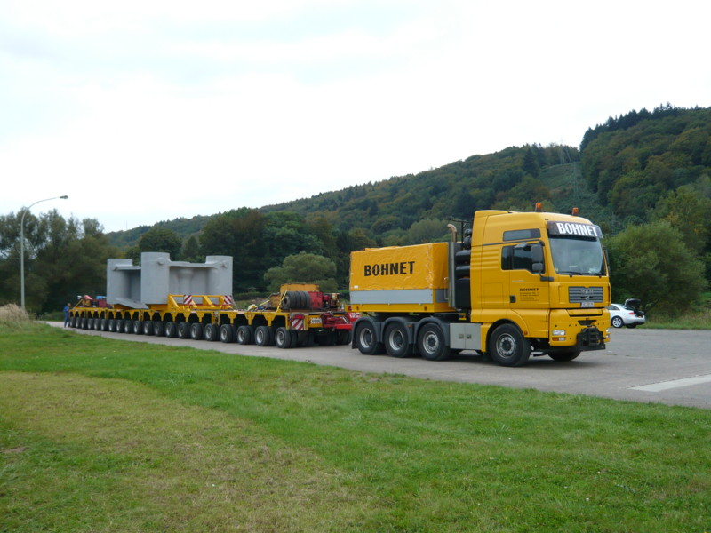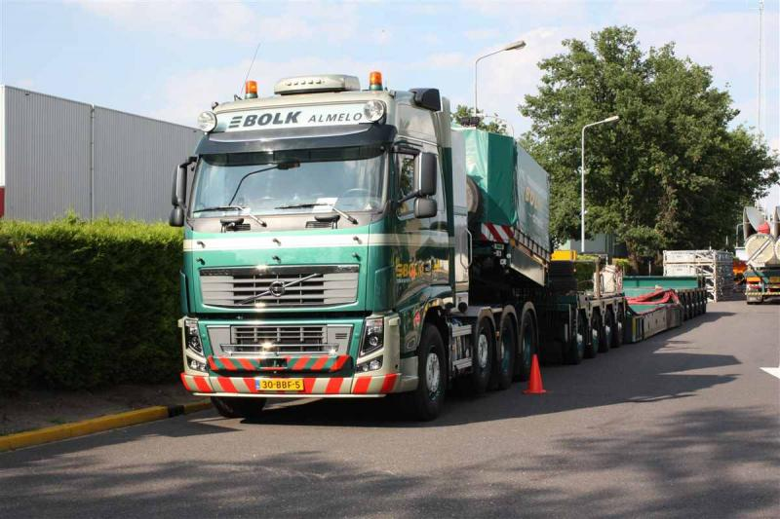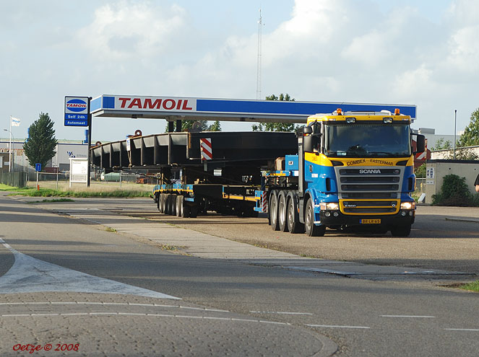  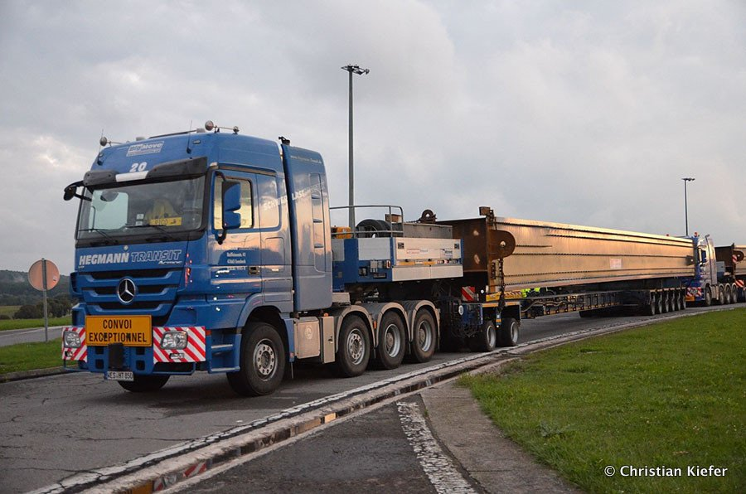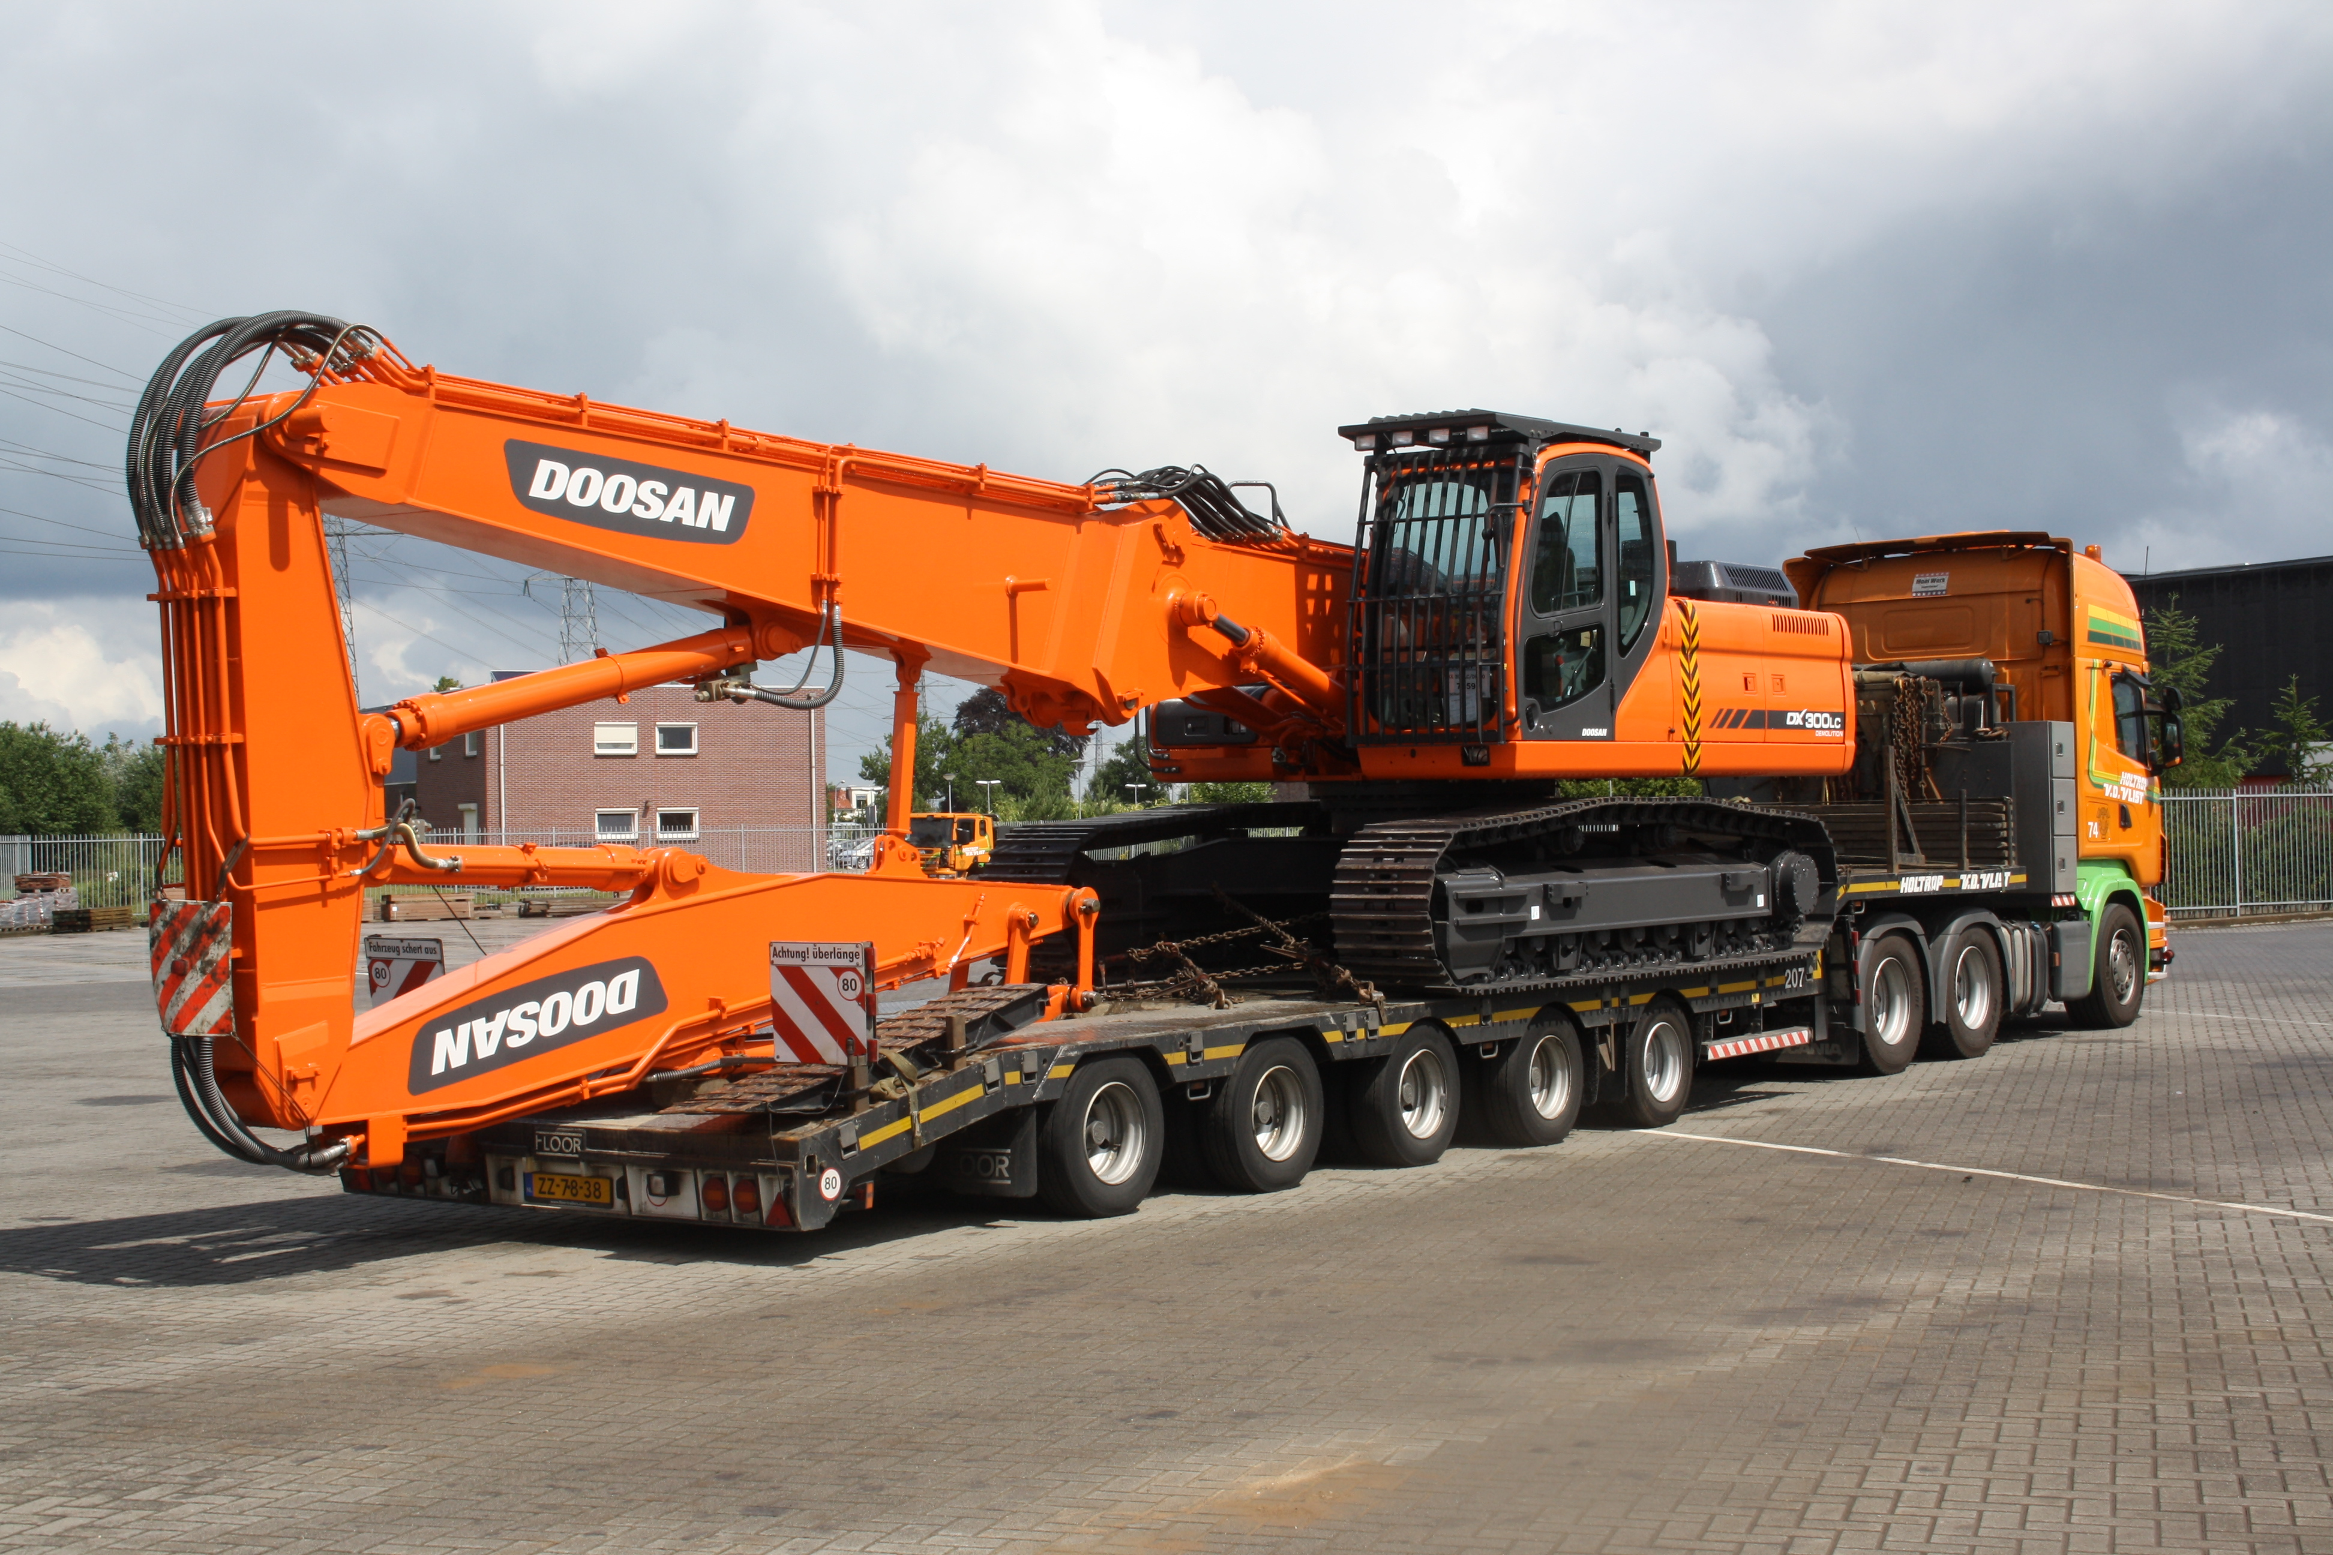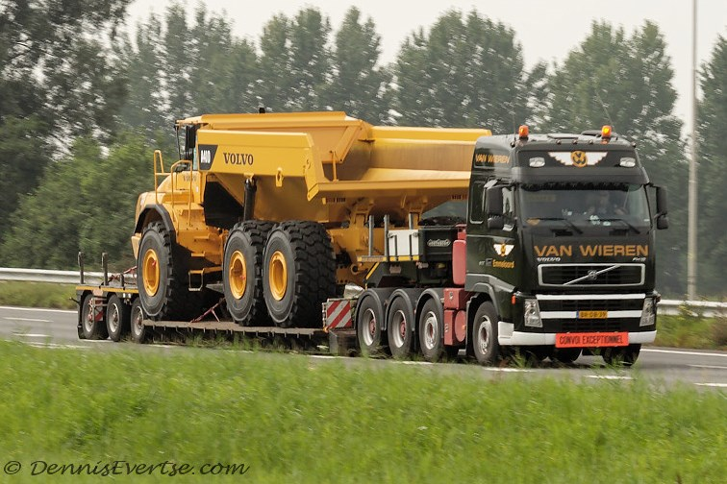
Construction, self-supporting loads up to 120 tons, hydraulic presses, heavy machinery, wind turbines, bridge parts, construction machinery and many other oversized loads. Contacts with 300+ Companies in Europe.

Curriculum Vitae
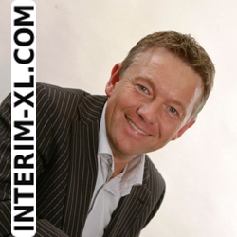

Name: Ing. Bouwe van der Meer
Graduate Logistics Manager (FH)

a De Line 16, 8411 TV Jubbega, NL
m +31 6 46 84 23 31
e info@interim-xl.com
w www.interim-xl.com
b 09-06-1970, 45 Years old

Resume in headlines

- Raised in a family business, a transport company and trade in garden articles
- First restructuring project at the age of 23 (sold transport department with 7 trucks)
- 15 interim projects finished since 2006, first project at the age of 36
- Specialized in negotiation techniques, both procurement and sales
- 30 years’ work experience trade, procurement, production, supply chain, transportation and logistics
- Strong background in IT, sales, procurement, distribution, manufacturing, buying and management
- Multilingual (NL, DE, UK) and employable worldwide

Outstanding projects and experiences

- Losses in freight and forwarding companies converted into profit
- Organizing workshops “turnaround marketing, how to escape the big squeeze”
- International business development projects and cold acquisition
- Strong negotiating technics and decisive in strategic sourcing / purchasing
- Restructuring of business processes, acquisition and financing of foreign companies
- IT systems such as Oracle, QAD, MFG-PRO, and Microsoft Dynamics implemented
- Optimization of total cost of ownership fleet management
- Optimization supply chains, warehousing, pick / pack, inbound and outbound procedures
- 10 X own MS ACCESS Tool developed, expert on SQL (massive data processing)

Buying experience

- European and worldwide transport (road, rail, river and sea, multimodal)
- Storage at third parties, warehouse equipment and forklifts
- Vehicle fleets (trucks, wheel loaders and cars), fuel and spare parts
- Raw materials for the concrete industry (sand, cement, additives)
- Advertising, DTP, photography, printing, brochures and digital media (internet)
- Computers (PCs, servers, board computers) and software (ERP, TMS)
- Office supplies, temporary workers, rent offices and premises

Branch and Countries

- Experience in industries: wind energy, transportation, logistics, healthcare, manufacturing, concrete products, building, laundry, merchandising, FMCG, food, automotive and electronics
- Experience in countries: UK, USA, Sweden, Germany, Poland, Switzerland, Austria, Belgium and France

Personal strengths

- Self-starter, honest and loyal, warm personality
- Can get along with both managers, owner / Stockholder and workers
- Very creative in finding solutions to “impossible” problems
- Innovative thinking and action, enthusiasm and perseverance
- Strong persuasion and excellent communication skills
- Proven references in managing complex projects
- Successful negotiations on the international level

Interim mandates and projects > 3 Months

Consultant Procurement and Logistics (80%) | 05/2015 – 12/2015
Enercon Gmbh, DE-Bremen, Wind turbines Producer, 4,6 billion. EUR, 20.000 FTE
- Supporting and advising department Logistics and Purchasing Transport and Cranes (cat spend 500 Mio)
- Supervise procurement projects and negotiating with vendors for projects in Europe
- Develop logistic calculations models for each country in Europe for Transport (Heavy) and Cranes (600 Tons)

Consultant Procurement and Logistics (20%) | 07/2014- 09/2014
Gräper Gmbh, DE-Ahlhorn, Concrete Transformation Houses producer, 100 Mio. EUR, 700 FTE
- Supporting and advising department Logistics and Purchasing
- Supervise procurement projects and negotiating with vendors
- Tender Transport and Cranes Europe (3 Mio)

Interim Category Lead Buyer (100%) | 12/2014 - 05/2015
Avebe Potato Starch, NL, 1300 FTE, 650 Mio. EUR
- Restructuring of procurement and organization of transport and warehousing worldwide (spend 70 Mio):
  - 2M tons Potatoes to factories, 600K tons of potato starch in bulk, big bags and pallets moved by road transport and maritime containers worldwide
  - Storage of packed goods (120.000 m2), bulk with external parties and external silo parks (200K ton)
- Issue Tenders and contract negotiating:
  - Transport and loading of containers to Rotterdam (saving €100K)
  - Internal transport of potato starch through bulk trailers (saving €400K)
  - Sea transport of maritime containers by shipping companies
  - Potato transportation from the field to the factory (saving €200K)
  - Road Transport Europe, 6.000 FTL loads (saving €500K)
- 5 new carriers selected and implemented for transport packages of 10M €
- Legal problems with suppliers solved using lawyers and attorneys
- Development and implementation of new purchasing strategy and multi-year procurement plan
- Further development of international intermodal freight volumes from road to rail / barge (saving €600K)
- Examined contracts of 20 vendors and decreased liability and risks
- Advised senior management in logistics / transportation on liability and litigation
- Implemented new negotiating techniques in renewing contracts with vendors.

Interim Manager Sales and Logistics | 02/2014 - 07/2014
Studio 100 Media, DE-München, Media Producer, 1000 FTE, 170 Mio. EUR
- Short term replacement of 2 Key staff members, Head of Merchandising and Supply Chain Manager
- Planning, buying and replenishment of 500 articles in China and Europe
- Liaise with headquarters Schelle Belgium demand, prices and European needs
- Negotiating and buying displays from cardboard factories
- Daily management and training employees department sales and logistics
- Optimize customer contracts, Supply Chain and SLA of with logistics service providers
- Research and development of new logistics model Europe (from 4 warehouses by 2)
- Optimization of Microsoft Dynamics AX (ERP) and creation of new reports (Crystal Reports)
- Write and ISO procedures for all processes in German language

Interim Logistics Manager / Interim Buyer | 09/2013 - 12/2014
Laundry service de Blinde, NL-Heerenveen, Healthcare, 200 FTE, 15 Mio. EUR
- Restructuring fleet management (technical and financial)
- Optimization of the material flow of clean and dirty bed sheets linen, textiles and clothing from the laundry to the hotel chains (300.000 kg pro week)
- Buying and selling trucks, fleet analysis, insurance and contacts with Department of Motor Vehicles
- Supplier management and auditing, maintenance and repair of vehicles
- Interim category buyer for Fuel (800K€), Trucks and parts (4M€) and Personal (400K€)
- Tenders, RFQ prepared and completed for road transport, labour and maintenance
- Release invoices through Purchase to pay, manage exceptions (2x bankruptcy’s suppliers)

Interim Business Development Manager |  | 05/2013 - 10/2013
Gutmann Heavy Logistics AG, CH-Zug, Heavy Transport Logistics, 100 FTE, 35 Mio. EUR
- Acquisition project cargo in Europe through cold calling, internet, emails, newsletters and presentations
- Branches: wind energy, power plant construction, steel mills, oil and gas and top 100 companies germany
- Design new website, brochures, newsletters and marketing strategy
- Buying and organization transport, cranes, special equipment for projects in Europe
- New offers to prospects: 2,5M€ with 250K€ turnover
- Attended trade fair Transport & Logistics Munich and Break Bulk in Antwerp
Interim logistics Manager / Buyer Logistics | 09/2013 - 02/2014
Rentex Floron BV, NL-Bolsward, Healthcare, 350 FTE, 33 Mio. EUR
- Improved efficiency planning trucks and creating 500K savings euro annually
- Decreased number of trucks from 34 to 24, sold old leftover trucks through internet auction
- Optimization of the material flow of clean and dirty bed sheets linen, textiles and clothing from the laundry to hospitals, nursing home, disabled (400.000 kg pro week)
- Interim Buyer for IT Systems, Fuel (1M€), Trucks (5M€) and Personal (400K€)
- Tenders, RFQ prepared and completed for road transport, labour and maintenance

Manager new business | 9/2010 – 2/2013
Holtrop van der Vlist BV, Heavy Transport and Machinery, 100 FTE, 18 Mio. EUR
- 120 new customers earthmoving industry, heavy equipment and 2 M € new revenue per year
- Define sales strategy and implement into sales plan, making prices and working on tenders (CAT)
- Management of 1000 Prospects (cold calling, newsletters, visiting) and 600 customers
- Responsible for accounts receivable management and contact person for major accounts and IT
- Hiring and purchasing contractors for special projects, road transport and sea freight
- Managed outbound automotive projects, export equipment through sea transport
- Development of own CRM Database and introduced GPS System TraSec
- Attended trade fair Transport & Logistics Munich and Break Bulk in Antwerp

Interim Commercial Director | 4/2007 - 9/2010
Oenema Transport, Taxi / ambulance, Transport and Logistics, healthcare, 200 FTE, 20 Mio. EUR
- Responsible for the staff, Transport Department 70 drivers and 5 office workers
- Restructuring transportation department, € 600 K annually loss converted
- Purchase / Buying of capital equipment such as trucks, forklift, fuel and temporary workers
- Negotiate tariffs with charters and other transport companies
- Set up new departments:
  - Automotive inbound logistics (10 trucks for Scania Zwolle)
  - Food and conditioned transport for Albert Heijn (12 trucks)
  - Furniture transport from Germany to Holland (3 trucks)
- 50 new clients and 2M € new turnover
- Selling department ambulance healthcare (5 M €) to Kijlstra Personenvervoer
- Preparation acquisition company through 2 sons and training in France
- 4 European tenders passenger transport disabled people to hospitals (€ 4M)
- Conducting litigation and contact person for banks, taxes, customers and suppliers
- Warehouse activities development (5,000 pallets) and cross docking for new clients

Interim Buyer and Logistics | 02/2008 - 05/2008
MBI Concrete Products, NL-Kampen, Concrete Production, 200 FTE, 35 Mio. EUR
- Optimizing flows of goods, storage of raw materials and finished goods
- Optimizing production Kampen NL (200.000 ton) and Veghel NL (300.000 ton)
- Tender and RFQ written for Outbound Transport finished goods and negotiate contracts
Interim Transport Manager | 01/2007 - 06/2007
Holcim Concrete Products, NL-Rotterdam, Concrete Production, 200 FTE, 30 Mio. EUR
- Planning, preparation and organization of transportation of building materials (Daily 80 trucks)
- Contact person for drivers, customers, freight forwarders and production staff
- Tender (RFQ) written for outbound transport finished goods and negotiate contracts

Interim Director | 07/2006 - 01/2007
Concrete Production Kijlstra, NL-Veendam, Concrete Production, 35 FTE, 20 Mio. EUR
- Heading team of 35 FTE, production, buying, sales, marketing and administration
- Buying all equipment like forklift trucks, wheel loaders, raw materials like sand cement and minerals
- Master production planning in SAP R3 and liaise plans with headquarters
- Solved production problems (interruptions) and prepared expansion of production to 200% in 2007
- Determine new marketing strategy (dealers and end customers) and define selling prices
- Turnaround marketing: create new product range called "Colors of the Earth"
- Managed 2 sales managers and took care of the biggest customers myself

Managing Director | 2/2001 -8/2006
Van der Werff Logistics BV, Transport and Logistics, 100 FTE, 12 Mio. EUR
- Responsible for the staff, Transport Department 75 drivers and 10 office workers
- Close and reorganize office Harderwijk (€ 3M and 25 trucks)
- Purchase / Buying of capital equipment such as trucks, forklift, fuel and temporary workers
- Acquisition and integration Hamstra Transport (30 trucks)
- Defined and implemented new tariff system for charters (based on miles)
- Growth of 3M € to 10M € in 5 years and 35 to 80 trucks in 5 years
- Development of warehouse operations, organize and build warehouse (10,000 tons)
- Tenders in transportation (€ 4M) and conducting litigation
- Contact person for banks, taxes, customers and suppliers
- Purchase and implementation TMS Plan and Go! (125K€) and Transics Boardcomputers (200K€)

Supply Chain Manager | 1/1996 – 1/2001
Xerox Distribution Europe BV, Electronic, 200 FTE, 200 Mio. EUR
- Demand Planning, Purchasing 3,000 articles in Mfg/Pro and Oracle, 20 M € value
- Organising inbound container shipments from USA, China, Korea to Europe
- Organising outbound worldwide shipments, pallets, parcels, and full trucks and air cargo
- Purchasing cardboard parts in the UK (€ 1M) and organize transport UK>NL
- Management internal logistics: storage and release of salesorders
- Planning production department of configuring printers to salesorders (also managing BOM’s)
- Responsible for shipments to customers in Europe, damages and organizing quarterly endings
- Organized the complete removal DC from Heerenveen to Venray (6.000 pallets)
- Transfer of inventories (€ 100M) and integrating all IT systems
- Implementation of QAD MFG / PRO and Oracle in Heerenveen and Venray (superuser level)

Interim mandates and projects < 3 Months

Interim Manager | 08/2014 - 09/2014
Inter-East Cargo BV, BU-Sofia, Transport, 15 FTE, 6 Mio. EUR
- Negotiated and sold GmbH including 12 Lease trucks and Bulgarian drivers to Schavemaker Beverwijk
- Defined and prepared all the financial contracts between buyer, lease company and seller

Consultant Business Development | 10/2014- 10/2014
Rail and Road Logistics, DE-Berlin, Heavy Project Cargo, 20 FTE, 13 Mio. EUR
- Organising 2 day Workshop „Turnaround Marketing, Social Media, Internet and Acquisition“

Consultant Business Development | 02/2013 - 02/2013
Max Wild, DE-Berkheim, Transport and Logistics, 450 FTE, 100 Mio. EUR
- Organising 2 day Workshop „Acquisition BAUMA Trade Fair München“ Heavy Equipment
- Consulting acquisition prospects Heavy Transport and project cargo

Consultant Business Development | 06/2005 - 07/2005
Buiter Beton, NL-Zwolle, Concrete Production, 28 FTE, 22 Mio. EUR
- Workshop „Internet und E-commerce“. Design and structure new Website

